GDE405 Readings & Assignments: Week 5

Week 5 Reading
Complete the following reading early in the week:
- The online lectures for Weeks 5 and 6.
- The following topics from the book, Drawing From Life by Clint Brown & Cheryl McLean:
  - Chapter 5: Value Light and Form
Week 5 Assignments Overview
Assignment Summary:Week 5 | Due
Assignment 1: Discussion Questions | Tuesday, November 4, 2008
Assignment 2: Fashion Drawing | Tuesday, November 4, 2008
Assignment 3: Creating Illustrations from Life | Thursday, November 6, 2008
Assignment 4: Abstract Figure Drawing | Thursday, November 6, 2008
Assignment 5: Complete Abstract Figure Drawing | Saturday, November 8, 2008
Remember that all assignment details can be found on the assignment pages located throughout the week. Go to those specific pages for direction on how to complete each individual assignment.

Week 5 Overview

Learning Outcomes:
- Render a fashion illustration according to the appropriate fashion design principles.
- Apply your personal style and approach to fashion illustration.
- Abstract a figure drawing using several approaches.
- Apply your personal style and approach to abstract figure drawing.

Fashion Illustration and Art
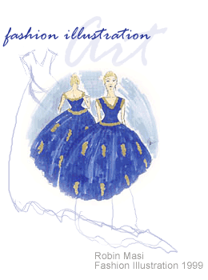
This week we will explore additional approaches and uses of dynamic figure drawing. In particular, we will look at the area of fashion illustration that uses the figure as a foundation and apply the principles of fashion illustration to how a fashion drawing is created.
We will abstract the figure and exaggerate certain aspects of the figure in order to explore additional approaches and techniques.
Fashion art is the art of combining clothing with the figure. It has been used as a record of how clothing is worn throughout history. Before the invention of photography, artists and illustrators were the chroniclers of how fashion evolved throughout the centuries. Any walk through a museum will show how fashion has changed over time through the artwork of all periods in history. Fashion art in the twentieth century is used by stores and designers to sell and chronicle their creations, and is part of the creation process itself. The fashion sketch or croquis is what the fashion designer uses to show the proportions and silhouettes of the clothing they are designing. When the design is complete, the sketch is used in the manufacturing process to be sure the final garment and the designer's idea match. To be a fashion artist you must have the technical knowledge of anatomy and drawing the human figure, have an understanding of clothing history, as well as a working knowledge of fashion.
Supplies
Fashion illustrators frequently use graphite to lay in the sketch and markers with watercolor washes to add color. Speed is of the essence in fashion drawing, aiming at the depiction of a quick and breezy sketch as opposed to a finished, rendered drawing. A fashion illustration appears to be effortless, which means the artist has to practice a combination of control and speed.

The Hold
Unlike figure drawing, the fashion illustrator holds the drawing tool as if you were going to write. This is due to the necessity of achieving a smooth, controlled, and flowing line.

Proportion
One of the main differences between a fashion illustration and typical human body drawing is the number of heads used to make up the body. As we know, the human form is between 6–7 1/2 heads tall. Classical Greek artists and painters from the Renaissance used an 8-head measurement, although Michelangelo was known to sometimes use a 9-head measurement. However, designers have found that the longer and more slender the form, the more attractive the garment appears. Therefore a 10-head measurement is the standard proportion used in fashion illustration (with some exceptions). Different garments will have a different focus, and therefore the parts of the body will change accordingly. If you are featuring a short skirt, the legs should appear longer. If you are featuring willowy, long sleeves, the arms will be slender and the hands elongated. If you are featuring a full skirt, the waist will be smaller than usual, etc.

Line Quality
Some garments require a lighter touch and others a heavier one. Since it is not a rendered piece, there should be an economy of how many lines appear in the sketch. Do not use ten strokes to make one line. The line quality of the skin and body should appear as smooth as possible. Any variation in line quality should be reserved for the garment only. Consider the difference in line quality of a mohair sweater as opposed to a silk evening gown.

Movement
As in any dynamic figure drawing, the fashion illustration is more interesting when it appears to have movement as opposed to a static, stiff quality. To achieve movement, curved lines should be used to determine the movement and pose of the figure. Curved lines should also be used to depict the garments themselves. The S-curve is one of the most classic and fashionable gestures or poses.

The Fashion Face
The typical fashion face differs from a real face because certain features are simplified and idealized. It is the ideal of what is considered beautiful or handsome at any given time. It is not a single woman or likeness, but a blending of races and types. Typical fashion face features include:
- Full lips
- Prominent nose
- High cheekbones
- 3/4" view of the face
- Flowing hair that frames the face

Abstraction and the Figure
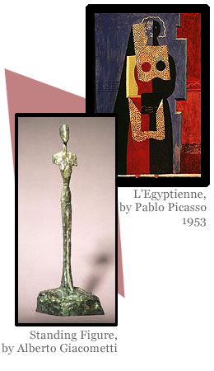
In the twentieth century, artists began to use the figure as a form of personal expression and a point of departure. Until that point the figure was realistically represented, with strict academic principles adhered to. With the birth of modernism, the figure has evolved from a very traditional to sometimes very cutting edge and contemporary form of art. Artists working today use the figure and the body as exciting forms of reference and exploration. Visit the contemporary wings of your local art museums and local galleries and explore how artists are using the figure in new and innovative ways.
Abstraction and the Figure
When looking at the drawings above by Pablo Picasso and Alberto Giacometti, it is clear to us that we are looking at drawings of figures. What is also clear is that they are not realistic renderings of the human form. They are abstracted drawings using the figure as a reference. When an artist uses the figure as a point of abstraction it becomes a reference point only. Accuracy, proportion, and realism are no longer the priorities, though these are essential in the artist's educational background.
In the Picasso drawing, he skews the placement of the parts of the body by making them into more geometric or cubist shapes, using black and white with no shades of gray and heavy black outline to flatten the forms. Picasso studied the work of African artists and their masks during this period of his career. He uses repeated patterning of stripes and curved lines to add a decorative feel to the piece. Lastly, he enlarges the feet or hands disproportionately to the rest of the form.
In the Giacometti drawing, the figure is elongated and stretched out as if being pulled by a rubber band on each end. The figure is floating in space with no sense of depth. It is clearly a female form by the emphasis on the breasts and genitals.
Studying how artists have abstracted and departed from the figure is another area of exploration in your own development of dynamic figure drawing. Using sources from the media, different periods in art history, and from real life are all excellent ways to explore how you can present your own view of the figure in an abstracted manner.
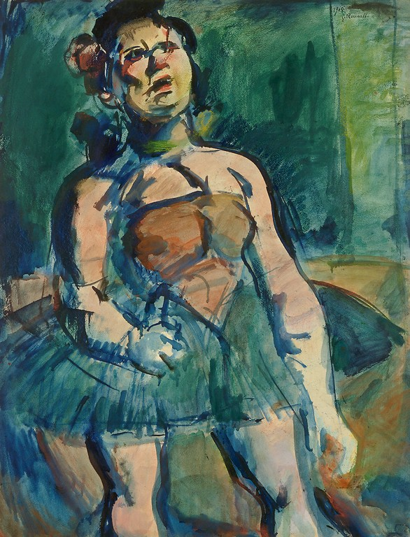
Ballet Dancer – George Rouault

Abstracting the Figure
Here are some techniques to try when working on abstracting an object or figure:
- Cropping the figure to the far left or right of the page (with parts of the body not able to be seen) presents the figure in a different way.
- Zooming in/blowing up certain parts of the body. Having the entire form shoot off all corners of the paper.
- Simplifying the shapes down to their most essential forms.
- Repeating/displacing body parts on different parts of the page.
- Turning the page at a 90-degree angle or upside down and adding elements within the new page orientation.
- Flattening lights/darks into bold patterns.
- Adding repetitive patterning.
- Dividing parts of the figure into geometric shapes.
- Dividing the figure into all softened/curved forms. Combine aspects of #6 and #7 from the previous page.
- Taking several existing figure drawings and using different parts of each to form another unique composition.
- Incorporating cut up magazines, newspapers, found objects, items from nature, etc. into the abstraction to expand the materials.
- Overlapping figures on top of one another. Using different colors and media to represent the different forms.
- Overlapping objects, patterns, and items from nature on or within areas of the figure.
- Altering your viewpoint: stand on a chair, sit on the floor and look at the model.
- Drawing a figure or series of figures from memory or a dream.
- Placing the figure in an environment and drawing in elements of that environment in a nontraditional way.

Creating Abstracted Figure Drawings

Abstract Drawing Exercises with Mixed Media
Explore abstracting the figure the following ways. Do not be afraid to combine approaches:
- Have your model hold a standing pose for 10 minutes. Create a typical figure drawing. Using just the drawing, flatten the dark points with black and whiten the light points with your eraser to have flat black and flat white areas. Add a color to the background with a brush and wash technique. Incorporate the color into the drawing. Add additional techniques that work with this basic technique to create an abstracted piece.
- Have your model hold a standing pose for 15 minutes. Obtain several old newspapers and cut out the contours of the form like a paper doll. Make sure you have several views—either front/back/side or body parts. Enlarge or make certain parts of the body small. Create a final composition and use your charcoal and pen and ink to integrate the materials.
- Have your model hold a seated pose for three minutes. Use a pen or marker. Sit in a chair and study the model and forms. Memorize them as best as you can. Have the model leave the room and draw the figure from memory. Do not let your tool leave your paper. You should have many lines going through the body. Speed up and slow down your stroke application. Use several different colors if you are comfortable with this technique.

Abstract Drawing Exercises with Mixed Media
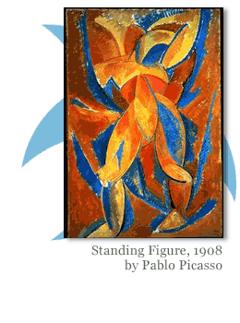
Explore abstracting the figure the following ways. Do not be afraid to combine approaches:
- Have your model pose for 30 minutes in a reclining side pose with his/her head resting on his/her hand. This exercise works best with a male model or female that has a very defined back shape. Create an intricate drawing of the back only to the base of the spine. Include only a portion of the head. Study and depict the intricate forms that make up the back. Take the drawing and create another drawing of one section that holds your interest.
- Have the model strike a pose that inspires you. Put out all of your art supplies in an organized manner next to you, ready to use. Put on your favorite CD at a reasonably loud level. Create a gesture drawing of the pose. Then take your least favorite/used form of media and approach the drawing from the perspective of spontaneity. Try to keep yourself as loose and open to the process as possible. Do not edit, erase or change any marks you make unless you add more strokes or color on top of what you've created. Add more media. Turn the paper on a 90 degree angle, then upside down. Work with the composition at 360 degrees and make the drawing work from all views.

Drawing Fashion Figures
Balance Line
After body proportions, the next component of a good fashion figure is a balance line, which helps you create a fashion figure without anomalies or abnormalities. Let’s look at what a balance line is and its importance in fashion drawing. Each drawn figure must have a sense of balance, or the figure will appear to be on the verge of toppling over. In most standing poses, the weight of the figure—represented by the balance line—falls at the center point between the two feet or directly beneath the ankle of the weight bearing leg. In life drawing, the head is usually directly above this point. In fashion drawing, the base of the neck is always directly above this point. The balance line is the key to any successful drawing. Utilizing that line correctly is what will ensure your drawing has stability and unity. The balance line depicts where and how the body bears its weight.
The balance line begins at the base of the neck and extends downward in a perfectly vertical line. If your figure is bearing weight evenly between its two feet, the balance line will fall evenly between those feet. As the figure shifts its weight from one foot to the other, the balance line also moves, as the weight of the entire figure must move. So if your figure is standing on its left foot, the majority of its body and ultimately its neck as well should be directly above the left foot. This is why it is important that you check the balance lines of all your figures after you’ve drawn them. Note the common mistakes you make, and try to be more conscious about not making them again. Lots of practice and hard work will ensure that your fashion figures are accurate and well-balanced.

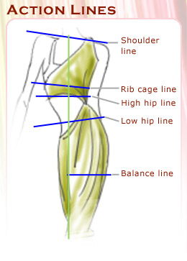
Action Lines, the C-Curve, and the S-Curve
After mastering proportion and balance lines, you should be able to draw still figures perfectly. But often you need to draw fashion figures that depict movement. The introduction of movement in fashion figures focuses at two key areas—the rib cage and the pelvic bone. Both these areas are the keys to representing the movement and attitude of the figure. These areas are represented by action lines and C- and S-curves in fashion drawing. Let's discuss them in detail.

Action Lines
Action lines include the shoulder line, the rib cage line, and the high and low hip lines. To understand action lines, it’s best to trace them on a fashion figure. To do so, first trace the shoulder line. Take a ruler or a pencil, place it across the figure and line it up with the ends of each shoulder. This is the shoulder line. Note the direction the shoulder line is leaning. Unless the figure is standing perfectly straight, it will lean one way or the other. Now take your pencil and place it at the bottom of the rib cage and line it up with the ends of the rib cage. Notice that the angle the rib cage line makes is perpendicular to the shoulder line.
Next, take a look at the pelvic bone. Again, take a ruler or pencil and place it horizontally along the high hip line. Notice the direction it leans toward and trace that line. Now take your ruler or pencil and place it at the low hip line or the bottom of the pelvic bone. Notice that the low hip line is now perpendicular to the top of the pelvic bone or high hip line.
The rib cage area and the pelvic area often move in opposing directions; but together they give meaning and attitude to your drawing.
Curves
Let’s now trace the curve on the fashion figure and determine the shape that the curve takes. Take a different colored pencil to trace the curve. To determine the shape of the curve, create a line that traces the center of the body, ensuring that the line moves vertically with the position of the body. This line is called the Center Front if the figure is facing you and the Center Back if the back of the figure is facing you.
To draw the center front or back lines, start at the base of the neck and end the line at the waist—let the line curve along with the position of the body. Then start the line at the waist and end at the base of the balance line. The Center Front should be created in two parts to see if the curve changes direction. The curve will either be shaped like a “C” or like an “S” and gives the figure a pleasing flow and the sense of balanced movement. In the first figure shown on the sidebar, note the presence of the curve only in the upper half of the figure. This is called the C curve because the remaining part of the curve is same as the balance line of the figure.
Look at the other examples on the sidebar to see how shoulder lines, hip lines, C-curves, and S-curves fall on the body in different poses. In these figures, the blue line indicates the balance line, the yellow line indicate the action lines, and the red line indicates the curve of the figure.
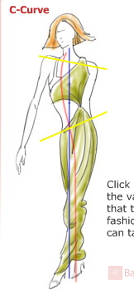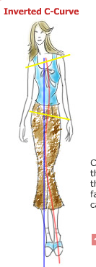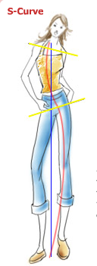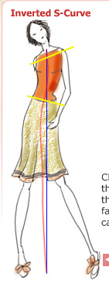

Illustrating Clothing: Basic Techniques
With fashion figure drawing basics under our belts, you can begin to illustrate clothing on fashion figures. The first step towards illustrating clothing is to simply draw it over the fashion figure. This is similar to sketching random garment designs that many of us are prone to do to fill our time!
But to make these illustrations look professional, you need to pay as much attention to clothes as you do to the actual figure. You need to emphasize on line weight, introduce colors, and use different medias to illustrate cloths. For example, if you want to draw a figure-hugging evening gown on a fashion figure, you'll first need to visualize how the dress would look when it is being worn. Following this you would need to outline the dress and rub off the parts of anatomy that should not be visible, knees and thighs being a prime example. Then you would need to add lines to depict the creases of the garment. Finally, you would need to add shading and colors to soften the lines and make the dress look as if the figure is actually wearing it.
To make the drawing more realistic, you can experiment with different types of papers and drawing tools to create the desired look. For example, the use of water colors in conjunction with marker pens would be useful to depict the texture of a material with strong lines. Additionally, you can use coarse paper to depict garments made from jute or other coarse fabric and can use smooth paper for garments made from silk.
As you may have noticed, drawing lines and adding color are important aspects of illustrating clothing realistically. Let’s take a look at some samples and see how simply adding or subtracting lines and color and using different media adds emphasis and creates a mood and attitude for a drawing.
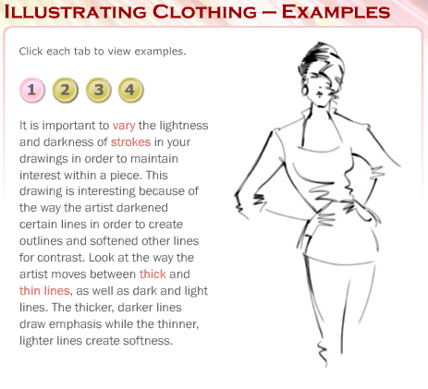
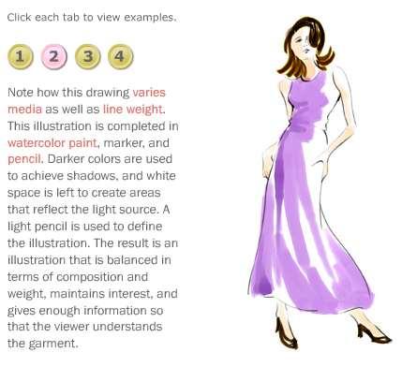
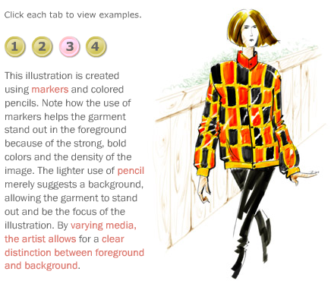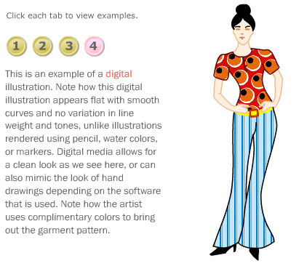

Assignment 1: Discussion Questions
By Tuesday, November 4, 2008, respond to the discussion questions assigned to you by the facilitator. Submit your responses to the appropriate topic in this Discussion Area. Start reviewing and responding to your classmates as early in the week as possible. You can ask questions or respond generally to the overall experience. Ensure to be honest, clear, and concise. Always use constructive language, even in criticism, to work towards the goal of positive progress.
Grading Criteria: | Maximum Points
Comments are clear and concise. | 4
Participates in the discussion with concise and clear comments. | 4
Student uses terminology and relates concepts introduced in course studies throughout discussion contributions. | 4
Student brings additional questions and observations into the discussion. | 4
Total: | 16
For assistance with any problems you may have when completing this assignment—OR—to offer your assistance to classmates, please use the Problems and Solutions Discussion area located through the left side navigation link.
- What is your experience with fashion and fashion illustration? Do you like it as an art form? Give reasons for your answer.

Assignment 2: Fashion Drawing
Complete these activities by Tuesday, November 4, 2008 and submit your drawings to this Discussion Area. Scan or shoot the drawings with a digital camera and save the image as a jpg file.
Review and critique the work of at least two other students. Post your comments by responding to the appropriate thread. You can ask questions or respond generally to the overall experience. Always be honest, clear, and concise, using constructive language, even in criticism, to work toward the goal of positive progress.
Curved Fashion Figure
Create one drawing using the “C” or “S” curve of your choice as described on the lecture: “Drawing Fashion Figures” pages 2 and 3. Use a 10 head fashion standard measurements, download the grid of such measurement from the lecture: “ Fashion Illustration and Art” page 2 . Use basic clothing or you can use a pose of a magazine as a reference.
Color the drawing using markers or color pencil. Also go over the lines with a thin black marker.
Grading Criteria: | Maximum Points
Ability to adhere to the fashion drawing principles outlined in the lecture. | 4
Application of personal style. | 4
Assignment submission on time. | 4
Participation in the discussion with concise and clear comments. | 4
Total: | 16
For assistance with any problems you may have when completing this assignment—OR—to offer your assistance to classmates, please use the Problems and Solutions Discussion area located through the left side navigation link.
Make this "feel" like a fashion illustration.
Assignment 3: Creating Illustrations from Life
By Thursday, November 6, 2008, complete this assignment. Submit the drawings to the this Discussion Area. Scan or shoot the drawings with a digital camera and save the image as a jpeg file.
Drawing your Model
Pose your model clothed with a garment that inspires you. Create a fashion illustration using the principles covered in Week 5.
The Fashion Face
Draw a self-portrait using the Fashion Face guidelines as described in the lectures of Week 5.
Review and critique the work of at least two other students. Post your comments by responding to the appropriate thread. You can ask questions or respond generally to the overall experience. Always be honest, clear, and concise, using constructive language, even in criticism, to work toward the goal of positive progress.
Grading Criteria: | Maximum Points
Ability to adhere to the fashion drawing principles outlined in the lecture. | 4
Application of personal style. | 4
Assignment submission on time. | 4
Participation in the discussion with concise and clear comments. | 4
Total: | 16
For assistance with any problems you may have when completing this assignment—OR—to offer your assistance to classmates, please use the Problems and Solutions Discussion area located through the left side navigation link.
Have fun with both of these drawings.

Assignment 4: Abstract Figure Drawing
The lecture on Techniques for Abstracting the Figure detailed several methods of abstracting the figure. Create several abstract gesture drawings using these methods. Just spend a few minutes on each approach. Submit your favorite by Thursday, November 6, 2008.
Scan or shoot the drawing with a digital camera and save the image as a jpeg file. Submit the file to this Discussion Area.
Review and critique the work of at least two other students. Post your comments by responding to the appropriate thread. You can ask questions or respond generally to the overall experience. Always be honest, clear, and concise, using constructive language, even in criticism, to work toward the goal of positive progress.
Grading Criteria: | Maximum Points
Applying the techniques as described in the lecture. | 4
Application of personal style. | 4
Assignment submission on time. | 4
Participation in the discussion with concise and clear comments. | 4
Total: | 16
For assistance with any problems you may have when completing this assignment—OR—to offer your assistance to classmates, please use the Problems and Solutions Discussion area located through the left side navigation link.
Abstraction can be a great means of expression. Explore it.

Assignment 5: Final Project Rough Draft
By Saturday, , submit a rough draft of the final project to this Discussion area. Scan or shoot the drawings with a digital camera and save the image as a jpeg file.
This project should incorporate and apply as many of the techniques and approaches you've learned in class as possible. These include:
- Accuracy in depicting the surface anatomy of the figure(s).
- Depiction of tension between the balance and active/passive sides of the figure(s).
- Incorporation of new media (charcoal, graphite, pen/ink, markers, pastels, water-based paint, etc.).
- Ability to render a final figure drawing.
- Awareness of the entire page and composition as a whole rather than a sketch or study.
- Resolution of the background.
- Resolution and demonstration of perspective/foreshortening.
Project Outline
- Using your model, do at least four gesture studies of different poses in a particular setting. Do not just have the model alone in your composition. Set the model up in an environment with a still life, outside, etc. In these drawings, play with space, composition, materials, etc., to decide the materials and approach to your final piece.
- Produce your final piece using the media of your choice.
- This project should take you about five hours to complete.
Review and critique the work of at least two other students. Post your comments by responding to the appropriate thread. You can ask questions or respond generally to the overall experience. Always be honest, clear, and concise, using constructive language, even in criticism, to work toward the goal of positive progress.
Grading Criteria: | Maximum Points
Applying the abstraction techniques as described in the lecture. | 4
Application of personal style. | 4
Using the approaches as described in the lecture. | 4
Completeness of drawing. | 4
Participation and constructive feedback in critique. | 4
Total: | 20
For assistance with any problems you may have when completing this assignment—OR—to offer your assistance to classmates, please use the Problems and Solutions Discussion area located through the left side navigation link.
This should start fleshing out your plans for the final project. This is a sketch. Keep it loose.

